**Structures**

* + **Arithmetic comparisos: ==, !=, <, <=, >, >=**
  + **Logic operators: and, or, not**
  + **+ - * ** / //div_norest %return0_if_clean_division**
* Loops
  + **While-loops (exit after condition is met) = while condition:**
  + 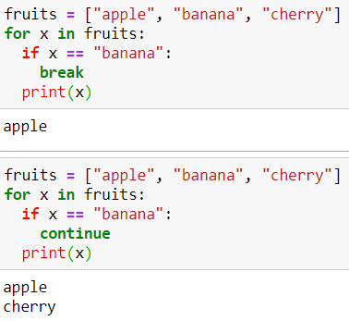**For-loops = for x in y:**
  + **break to interrupt**

**Datatypes**

* None
* Numerical
  + **Boolean**
  + **Int, float**
  + **complex**
* str
* list (ordered, indexed, duplicates) []
* tuples (ordered, unchangeable, duplicates) ()
* set und frozenset (unordered, unindexed, no duplicates) {}
* dict – Wörterbücher (unordered, changeable, no duplicates, immutable keys) {<key>:<value>}
* file

**Limit of ,**

* Floating point numbers approximate mathematical numbers. Numbers are stored in binary (32 or 64), which ensures that the rounding is not "obvious" when considering the decimal notation.

|  |  |
| --- | --- |
| range() | start, end, step |
| len() | Length of something |
| enumerate() | return set with number and content |
| **String** | **Description** |
| [capitalize()](https://www.w3schools.com/python/ref_string_capitalize.asp) | Converts the first character to upper case |
| [count()](https://www.w3schools.com/python/ref_string_count.asp) | Returns the number of times a specified value occurs in a string |
| [endswith()](https://www.w3schools.com/python/ref_string_endswith.asp) | Returns true if the string ends with the specified value |
| [expandtabs()](https://www.w3schools.com/python/ref_string_expandtabs.asp) | Sets the tab size of the string |
| [format()](https://www.w3schools.com/python/ref_string_format.asp) | Formats specified values in a string |
| [index(x)](https://www.w3schools.com/python/ref_string_index.asp) | Returns index (position) of ‘x’ |
| [isalnum()](https://www.w3schools.com/python/ref_string_isalnum.asp) | Returns True if all characters in the string are alphanumeric |
| [isalpha()](https://www.w3schools.com/python/ref_string_isalpha.asp) | Returns True if all characters in the string are in the alphabet |
| [isdecimal()](https://www.w3schools.com/python/ref_string_isdecimal.asp) | Returns True if all characters in the string are decimals |
| [isdigit()](https://www.w3schools.com/python/ref_string_isdigit.asp) | Returns True if all characters in the string are digits |
| [islower()](https://www.w3schools.com/python/ref_string_islower.asp) | Returns True if all characters in the string are lower case |
| [isnumeric()](https://www.w3schools.com/python/ref_string_isnumeric.asp) | Returns True if all characters in the string are numeric |
| [isspace()](https://www.w3schools.com/python/ref_string_isspace.asp) | Returns True if all characters in the string are whitespaces |
| [isupper()](https://www.w3schools.com/python/ref_string_isupper.asp) | Returns True if all characters in the string are upper case |
| [join()](https://www.w3schools.com/python/ref_string_join.asp) | Joins the elements of an iterable to the end of the string |
| [lower()](https://www.w3schools.com/python/ref_string_lower.asp) | Converts a string into lower case |
| [maketrans()](https://www.w3schools.com/python/ref_string_maketrans.asp) | Returns a translation table to be used in translations |
| [partition()](https://www.w3schools.com/python/ref_string_partition.asp) | Returns a tuple where the string is parted into three parts |
| [replace()](https://www.w3schools.com/python/ref_string_replace.asp) | Returns a string where a specified value is replaced with a specified value |
| [split()](https://www.w3schools.com/python/ref_string_split.asp) | Splits the string at the specified separator, and returns a list |
| [splitlines()](https://www.w3schools.com/python/ref_string_splitlines.asp) | Splits the string at line breaks and returns a list |
| [startswith()](https://www.w3schools.com/python/ref_string_startswith.asp) | Returns true if the string starts with the specified value |
| [strip()](https://www.w3schools.com/python/ref_string_strip.asp) | Returns a trimmed version of the string |
| [swapcase()](https://www.w3schools.com/python/ref_string_swapcase.asp) | Swaps cases, lower case becomes upper case and vice versa |
| [title()](https://www.w3schools.com/python/ref_string_title.asp) | Converts the first character of each word to upper case |
| [translate()](https://www.w3schools.com/python/ref_string_translate.asp) | Returns a translated string |
| [upper()](https://www.w3schools.com/python/ref_string_upper.asp) | Converts a string into upper case |
| **List/Array** | **Description** |
| [append(x)](https://www.w3schools.com/python/ref_list_append.asp) | Adds an element at the end of the list |
| [clear()](https://www.w3schools.com/python/ref_list_clear.asp) | Removes all the elements from the list (empty list) |
| [copy()](https://www.w3schools.com/python/ref_list_copy.asp) | Returns a copy of the element |
| [count(x)](https://www.w3schools.com/python/ref_list_count.asp) | Returns the number of elements with the specified value |
| [index(x)](https://www.w3schools.com/python/ref_list_index.asp) | Returns the index of the first element with the specified value |
| [insert(n)](https://www.w3schools.com/python/ref_list_insert.asp) | Adds an element at the specified position |
| [pop(n)](https://www.w3schools.com/python/ref_list_pop.asp) | Removes the element at the specified position |
| [remove(x)](https://www.w3schools.com/python/ref_list_remove.asp) | Removes the first item with the specified value |
| [reverse()](https://www.w3schools.com/python/ref_list_reverse.asp) | Reverses the order of the list |
| [sort(reverse=False)](https://www.w3schools.com/python/ref_list_sort.asp) | Sorts the list |
| **Set** | **Description** |
| s.union(x) | union of sets. Duplicates are nonexistant. No order |
| s.intersection(x) | intersection elements of two sets |
| s.difference(x) | return values s-x (like doing s1–s2) |
| s.symmetric_difference(x) | s and x without intersection |
| s.disjoint(x) | True have intersection or False if they have no intersection |
| s.issubset(x) | is all of s a part of x (<= operation) |
| s.issuperset(x) | check if x is subset of s (s is superset of x) |
| s.update([new]) |  |
| s.add .remove .discard .pop .clear | add(x) to set, remove(x) from set, discard(x) from set NO EXPCETION RAISED if missing, pop() is like normal pop, clear() also |

**Funktiondefinition Lists**

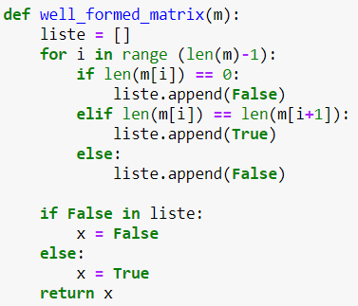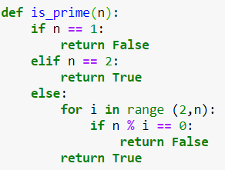

**Exceptions Comprehensions**

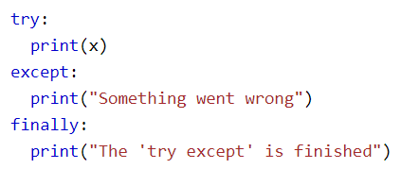

**Prime:**

**

**Conway GOL:**

**Error counter in txt file**

**Find 2 values from a list, that sum to 2020 Transpose a matrix**

**Matrix multiplication Matrix addition**

